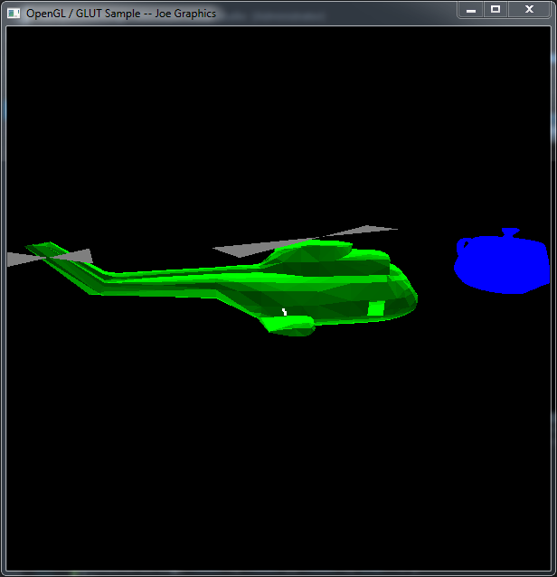

Video Link: https://media.oregonstate.edu/media/t/0_qqq7c0r5